Building Your Digital Bookshelf
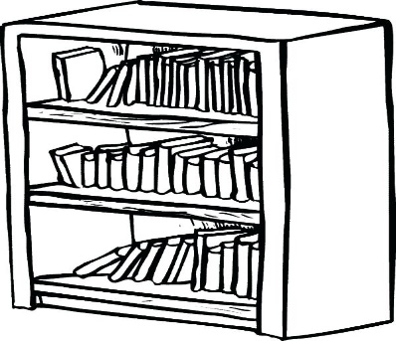
What books are online?
Books that are in the public domain (no longer under copyright)
Where to find Digital books for free
Google Books
https://books.google.com/
Internet Archive
https://archive.org/
HathiTrust
https://www.hathitrust.org/
Family Search
https://www.familysearch.org/
National Archives list of State Archives
https://www.archives.gov/research/alic/reference/state-archives.html
Pay sites
Ancestry https://www.ancestry.com/
Heritage Quest (Must get through a participating library. TCCL no longer has this subscription)
Genealogybank.com https://www.genealogybank.com/
Each site has different way to view, download or print books.
Google offers full view, limited preview and snippet view.
Google also offers you the option of building an online bookshelf.
Internet Archive
This site is a non-profit. Only has full view. Books can be downloaded or printed. You can also borrow a book for a limited time.
This site has more download options than google books, including Kindle.
Hathi Trust
You read books online and on their mobile app. They can also be downloaded.
Family Search (Mormon church)
They have many family histories that have been donated to their collection.
Their site is often slow.

